Data Providers

## Custom SQL Query

**Locks Older Than 24 Hours**

Reports the current number of batch, disk group and document locks.

SELECT 'Disk Group Locks' [LockType], COUNT(*) [CurrentLocks], **0** [Threshold]

FROM hsi.lockkeys

WHERE keykeytype = **64**

AND locktime < GETDATE() - **1**

UNION ALL

SELECT 'Batch Locks', COUNT(*), **0**

FROM hsi.lockprocess

WHERE locktime < GETDATE() - **1**

UNION ALL

SELECT 'Document Locks', COUNT(*), **0**

FROM hsi.lockkeys

WHERE keykeytype = **4096**

AND locktime < GETDATE() - **1**

**Uncommitted Batches**

Reports the number of uncommitted scanned batches vs. a threshold value set as a parameter (defaulted to 500).

SELECT COUNT(*) [CurrentTotal]

, **@{threshold}** [Threshold]

FROM hsi.archivedqueue aq

CROSS JOIN hsi.parsedqueue pq

WHERE aq.[status] <> **8** AND pq.[status] <> **8**

**Uncommitted Scanned Batches by Status**

Reports the number of uncommitted scanned batches by status.

SELECT

CASE [status]

WHEN **0** THEN 'Awaiting Index'

WHEN **1** THEN 'Index In Progress'

WHEN **2** THEN 'Awaiting Commit'

WHEN **3** THEN 'Incomplete Commit'

WHEN **4** THEN 'Incomplete Commit'

WHEN **5** THEN 'Incomplete Commit'

WHEN **6** THEN 'Incomplete Commit'

ELSE 'Other'

END [status]

, COUNT(*) [count]

,CASE [status]

WHEN **0** THEN **10**

WHEN **1** THEN **20**

WHEN **2** THEN **0**

WHEN **3** THEN **0**

WHEN **4** THEN **0**

WHEN **5** THEN **0**

WHEN **6** THEN **0**

ELSE **0**

END [threshold]

FROM hsi.archivedqueue

WHERE [status] <> **8**

GROUP BY [status]

**Failed User Logins**

Reports the number of failed logins per user.

select

sl.securitylognum,

case sl.subactionnum

when **1** then 'Client'

when **2** then 'Config'

when **9** then 'Core Services'

else 'Unknown'

end as 'subsystem',

sl.logdate,

sl.messagetext,

ua.usernum,

RTrim(ua.username) username,

ua.institution,

ua.realname,

ru.registernum,

ru.registername

from hsi.securitylog sl, hsi.useraccount ua, hsi.registeredusers ru

where sl.actionnum = **1**

and sl.subactionnum = **7**

and sl.usernum = ua.usernum

and sl.registernum = ru.registernum

and sl.logdate between **@{logrange}**

and ua.usernum = ##OB_OPTIONSELECT_ALL{(**@{usernum}**, -**1**)}

**User Login Activity**

Reports the number of successful logins per client per user.

select

sl.securitylognum,

case sl.subactionnum

when **1** then 'Client'

when **2** then 'Config'

when **9** then 'Core Services'

else 'Unknown'

end as 'subsystem',

sl.logdate,

sl.messagetext,

ua.usernum,

RTrim(ua.username) username,

ua.institution,

ua.realname,

ru.registernum,

ru.registername

from hsi.securitylog sl, hsi.useraccount ua, hsi.registeredusers ru

where sl.actionnum = **1**

and sl.subactionnum = **7**

and sl.usernum = ua.usernum

and sl.registernum = ru.registernum

and sl.logdate between **@{logrange}**

and ua.usernum = ##OB_OPTIONSELECT_ALL{(**@{usernum}**, -**1**)}

## Document Query

**Document Counts by Document Type**

Returns data about the Document Types selected at runtime.

**Document Types with System Keywords**

Reports on the documents for specific Document Types selected at runtime.

## Workflow Activity

**Workflow Activity for Ad Hoc Tasks**

Reports on the execution of ad hoc tasks for queues selected at runtime.

**Workflow Activity for Transitions**

Reports on how items transitioned through Workflow for the Workflow Queues selected at runtime.

## Workflow Inbox

**Workflow Inbox Contents**

Reports on the items that are currently in the Workflow Inbox for the Workflow Queues selected at runtime.

Dashboards

## Queue Contents and Entry Times Monitoring

This dashboard is used to present data about the contents in particular Workflow Queues that are selected at run time. It also gives users the ability to open a particular queue from the Life Cycle Document Data Grid.

Data Providers:

* Workflow Inbox Contents

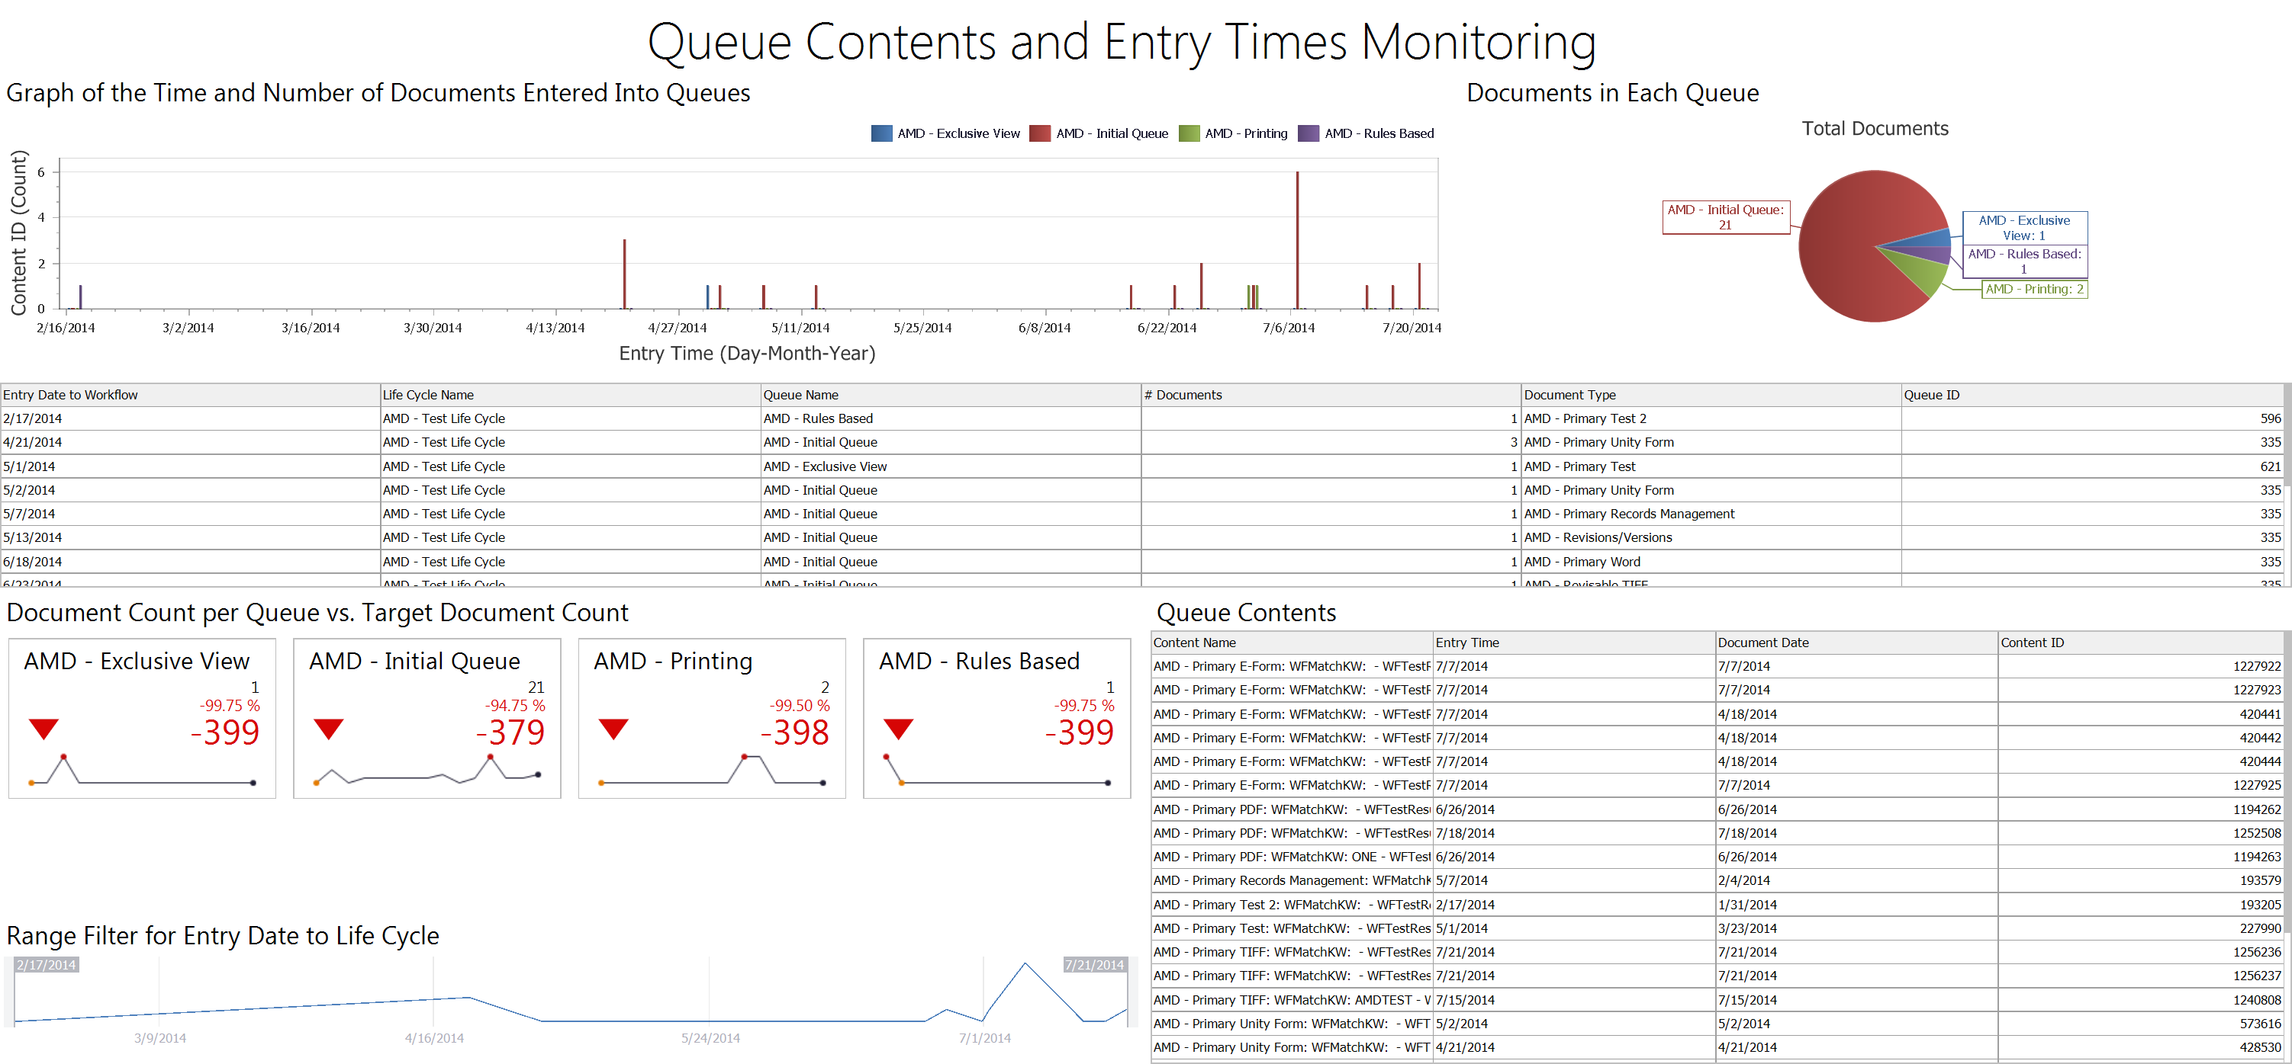

## Monitoring Workflow Activity for a Queues

This dashboard is used to monitor how items moved through Workflow Queues and how users interacted with them in the process.

Data Providers:

* Workflow Activity for Ad Hoc Tasks
* Workflow Activity for Transitions

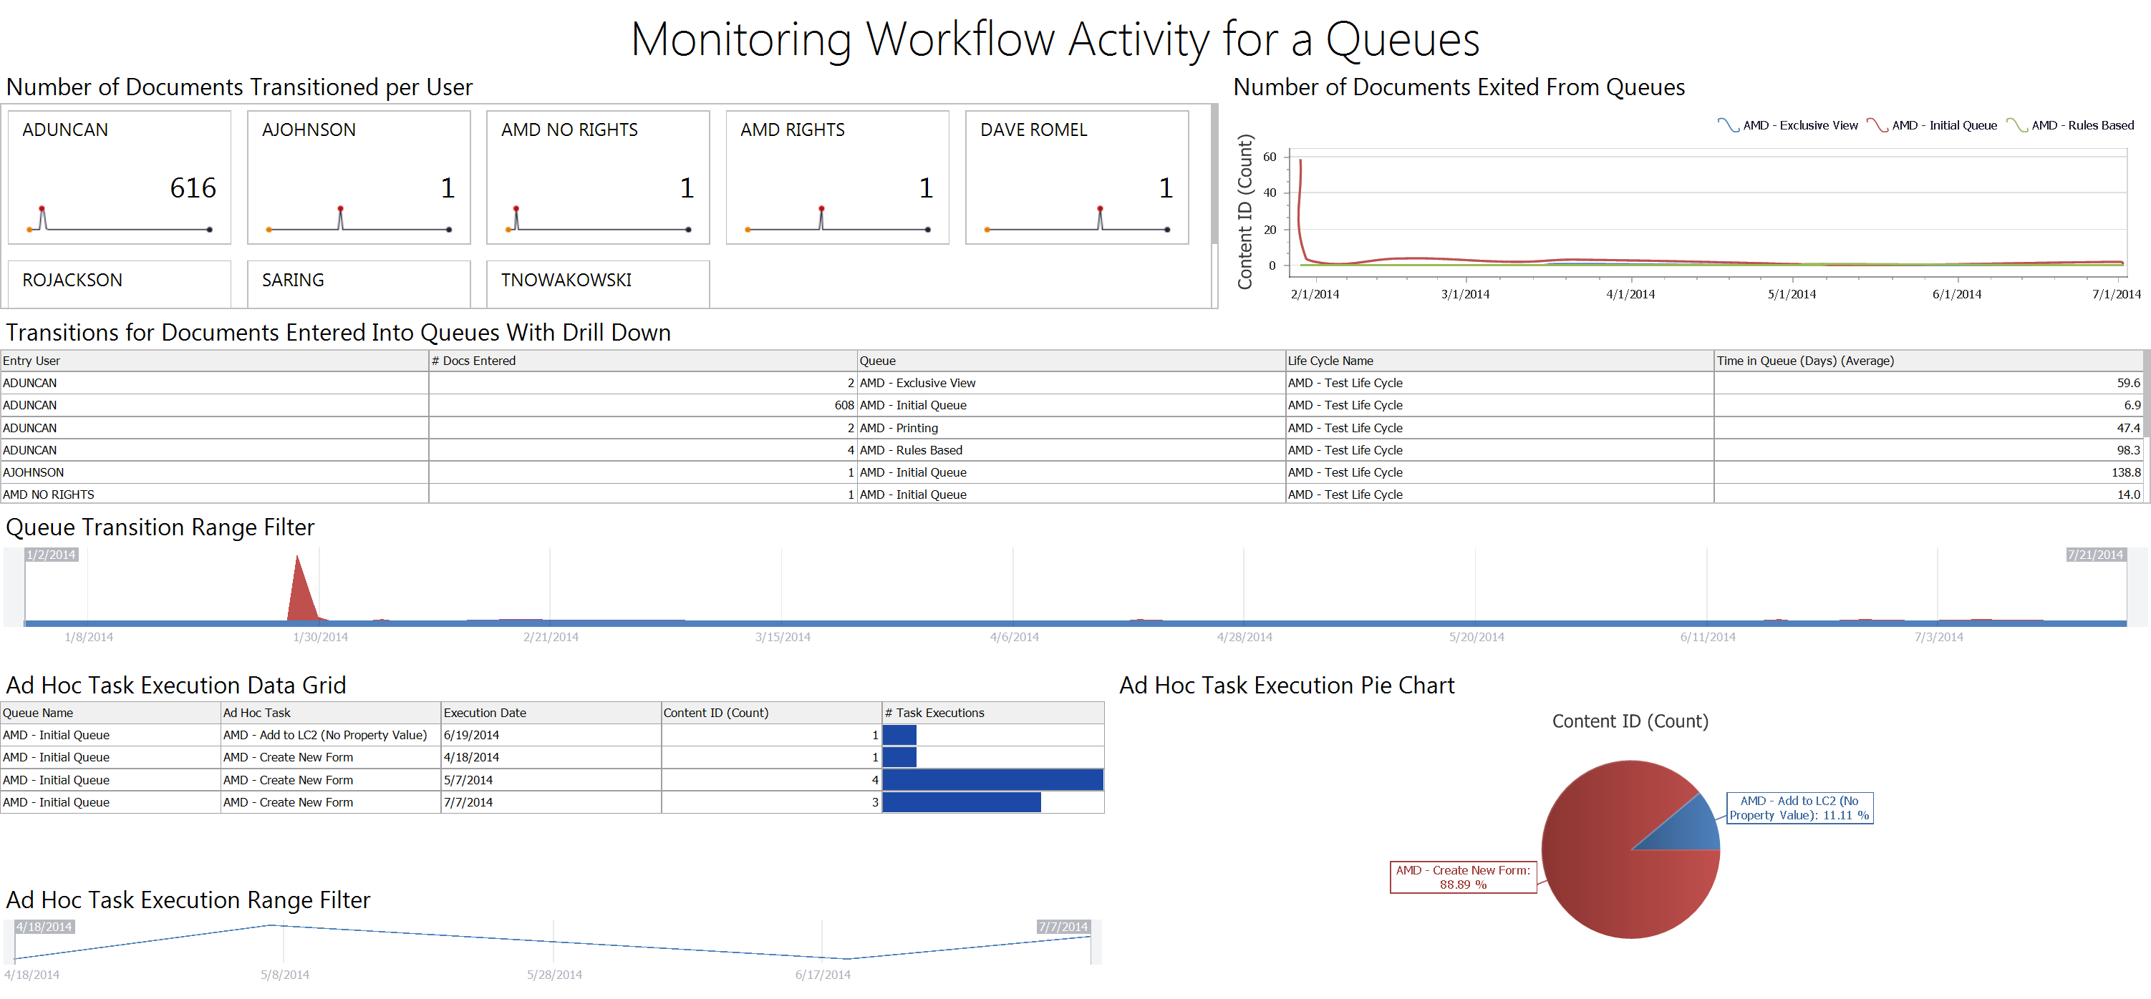

## Administrative Overview

Dashboard for tracking uncommited batches and the current system locks.

Data Providers:

* Locks Older Than 24 Hours
* Uncommitted Batches
* Uncommitted Scanned Batches by Status

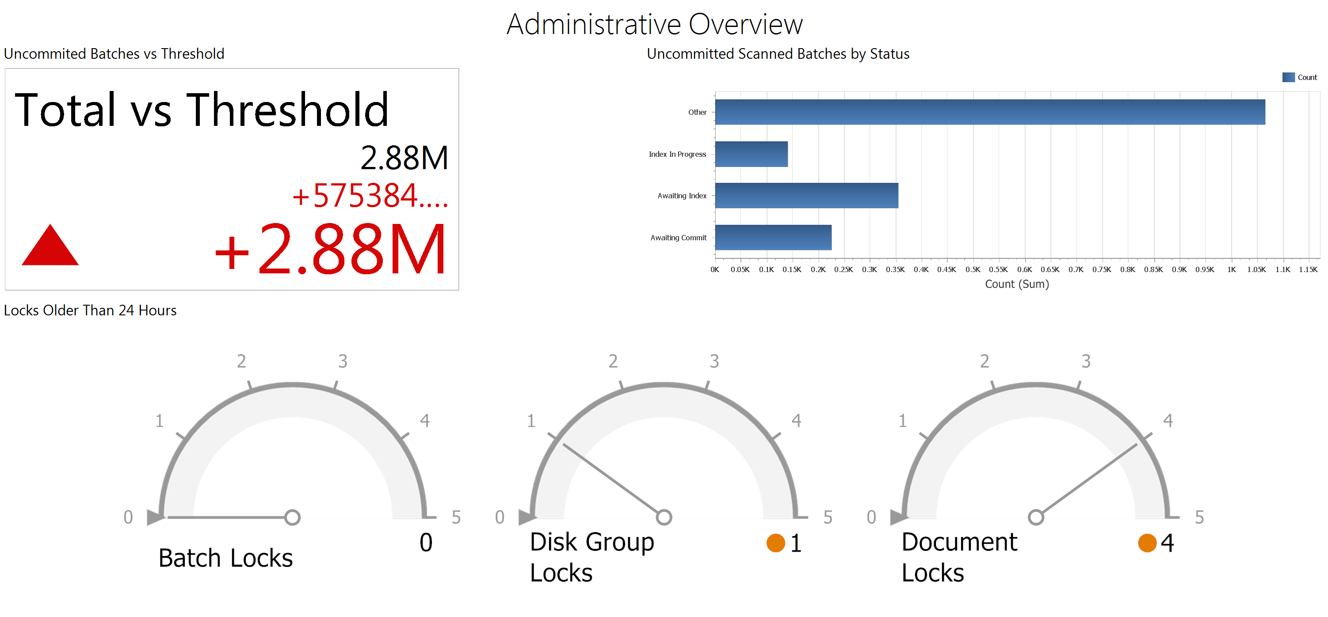

## Document Counts by Document Type

Breakdown of when documents were created and whom they were created by per Document Type. The dashboard also contains a list of the documents with the ability to select and display a document.

Data Providers:

* Document Counts by Document Type

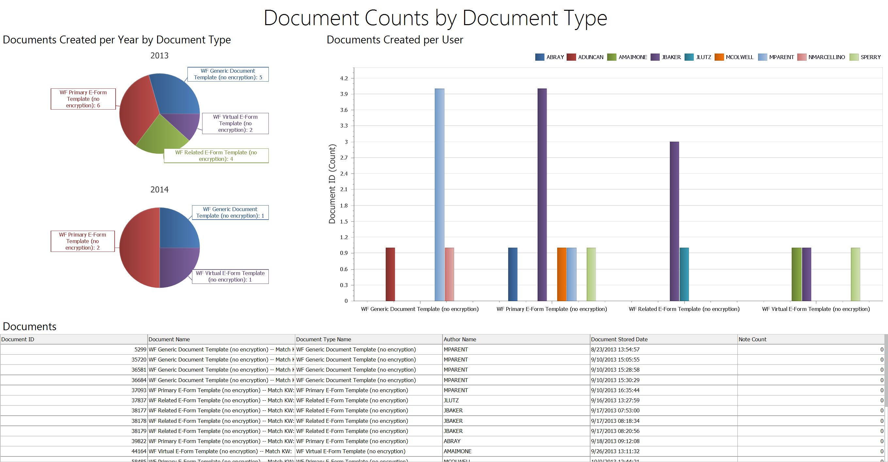

## Analyzing Documents of Specific Document Types

This dashboard is used to display data about documents of a specific Document Type in Workflow.

Data Providers:

* Document Types with System Keywords

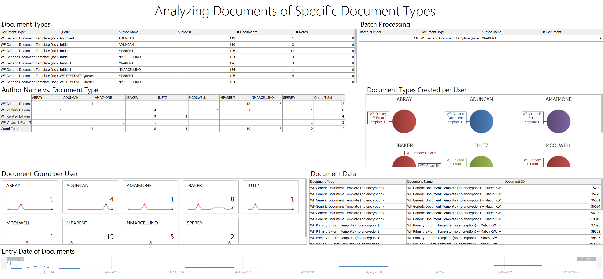

## Successful User Logins and Failed Logins Monitoring

This dashboard tracks user login activity for specific users. It displays data related to failed and successful logins.

Data Providers:

* Failed User Logins
* User Login Activity

